Referat Laborator 4 - Electronica Digitala

## Dumitrache Adrian-George

## 324CC

# Simulare NOT

# Simulare NAND

Semnale identice:

Semnale opuse:

# Simulare NOR

Semanale identice:

Semnale opuse:

# Simulare OR

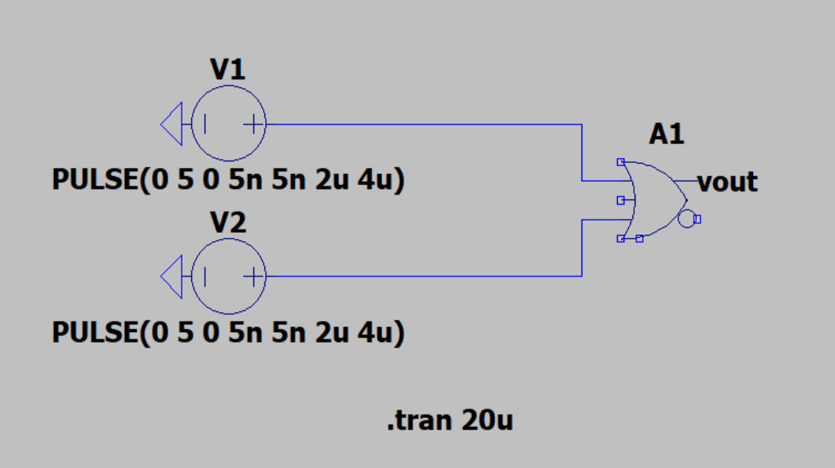

Semnale identice:

Semnale opuse:

# Simulare AND

Semnale identice:

Semnale opuse:

# Simulare XOR

Semnale identice:

Semnale opuse:

# Simulare XNOR

Semnale identice:

Semnale opuse:

